From: https://davidstockmanscontracorner.com/the-curse-of-keynesian-central-banking-part-5/
The Curse Of Keynesian Central Banking, Part 5
By David Stockman. Posted On Tuesday, September 17th, 2019
Keynesian central banking is the mortal enemy of capitalist prosperity. And if you take off your recency-bias goggles the evidence is plain as day.
What we are saying is that the Fed had virtually nothing to do with the economic growth delta's reported each quarter or even for a string of quarters. And that's notwithstanding all the back-patting in the Eccles Building and the financial press' unexamined presumption that what the Fed claims is the actual truth of the matter.
The fact is, the quarterly GDP prints are riddled with measurement noise; represent the underlying propensity of capitalism to relentlessly shinny up the slope of growth unless blocked by the state; and are washed with the cross currents of the world's $80 trillion economy that are far beyond the Fed's ability to control.
We prefer the figure for real final sales because it is GDP at the end of the day, but it excludes the short-run stocking and destocking fluctuations which distort the current period headline figure, even though they end up in the wash over time.
However, a drunken sailor would likely have a steadier hand on the tiller than represented by the annualized growth rate chop in the chart below. During the eight and one-half years since the US economy steadied itself from the Great Recession, quarterly growth has exceeded 4% four times (BTW, twice each under Obama and Trump), printed short of 1% eight times and the rest of the time was all over the lot in-between.
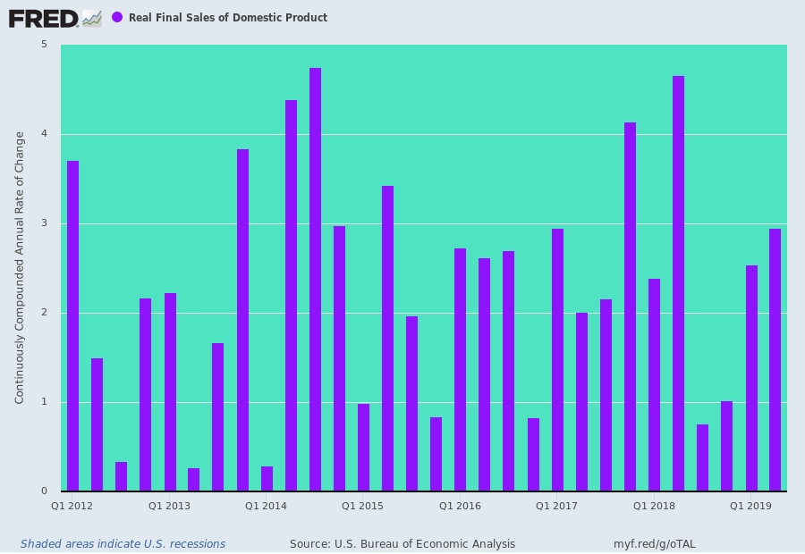
Nor does the chop go away entirely when you average over six month periods. Bernanke had the gall to claim the Fed had perfected the art of business cycle management to such a fine-tuned degree that the present era could be called the Great Moderation.
We think not. The pace of economic expansion fluctuates greatly even in the medium term, and we think there is not much evidence that the Fed has moderated anything.
What it does do is essentially wave its arms. That is, it claims credit for adroit policy when the bars in the chart are on the higher end of the range, while gumming about what it believes to be the external forces causing lower end outcomes (trade war headwinds being the latest), musing about how long they might last (transient or not) and postulating what the Fed's current and potential policies (forward guidance) might do to ameliorate sub-par growth prints.
The truth is, this is all self-serving Fed-speak. It's an arbitrary narrative of the central bank priesthood that is not based on any quantitative science whatsoever with respect to the exact transmission channels through which its policies operate or the lag time between action and effect.
But if you can't quantify either the channel or the time lag, you can say anything. And they do.
In the best case, therefore, Fed policy making and implementation is an arbitrary economic art, and in the more realistic sense its just central banker voodoo.
They try to conger macroeconomic outcomes with tools---interest rate pegging and bond buying---that can't possibly move a $20 trillion US economy or the $80 trillion global economy in which the former is inextricably intertwined, and by the day and hour owing to massive global financial markets and instantaneous global communications networks.
In short, the Fed's claims to be actively managing the US economy and business cycle are pretty much fake. Whatever they said about the ups and downs in the chart below---other than the 2008 meltdown and Great Recession----was just self-serving narrative.
And the deep collapse in the shaded recession columns of the chart were the collateral effects of bursting financial bubbles, which they Fed denied will they were inflating, and accepted no responsibility for after they burst.
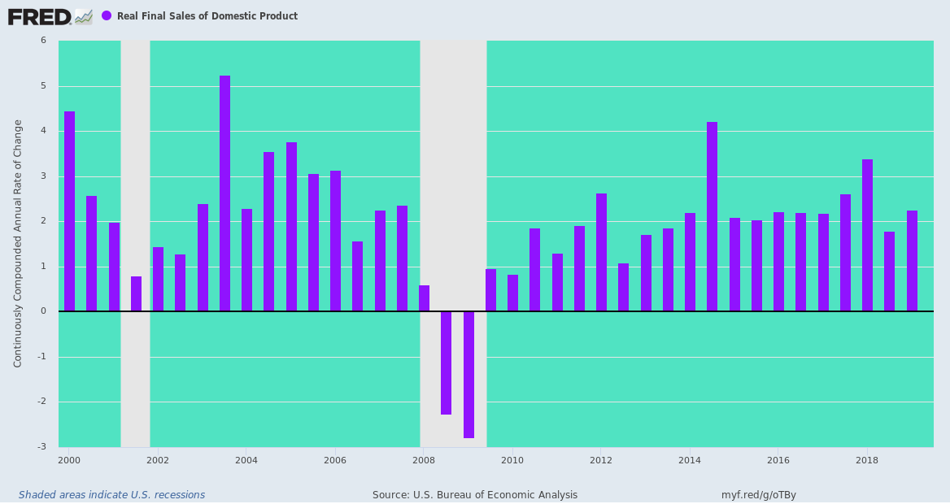
However, when it comes to the longer-run trend of things the untoward and unintended impact of the Fed's incessant "policy" making and fine-tuning is plain to see. That is, the more intrusive the Fed has become, the worse have been the main street outcomes.
The fact is, there has been no big structural change in economic life in America that should have caused a drastic decline in the real GDP growth rate. Arguably, in fact, the technological revolution since the rise of the internet in the 1990s should have actually given a boost to the growth rate, all other things equal.
Except, of course, they were not. The drastic decline in the trend rate of US economic growth (measured as 10-year rolling average of real GDP change) has been co-terminus with the post-1987 rise of aggressive monetary central planning at the Fed.
At the end of the day, what
- Greenspan/
- Bernanke/
- Yellen/
- Powell
have delivered is a 60% shrinkage in the trend rate of real economic growth (from 3.7% per annum over 1958-87 to 1.5% at present), thereby causing main street living standards to essentially stagnate since the late 1980s, posting a miniscule 0.38% annual growth rate (compared to 2.5% per annum during 1954-1974).
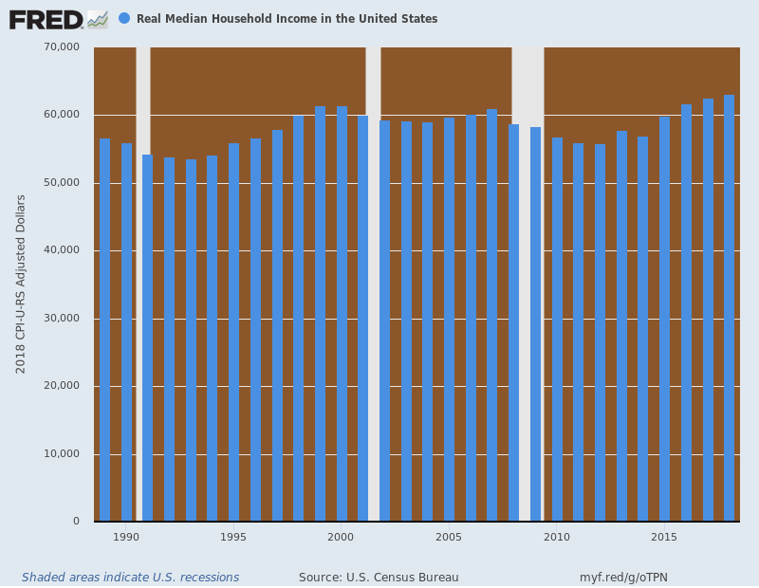
In the days of
- William McChesney Martin (1951-1970),
- Arthur Burns (1970-1978) or
- the great Paul Volcker (1979-1987)
no Fed chairman would have dreamed of keeping the money market rate below the inflation rate for 126 months running (April 2008 to December 2019) as did the current Fed.
Nor would any Fed head have even contemplated---sober or soused---increasing the Fed's balance sheet from $500 billion to $4.5 billion [trillion] in just 14 years (2000 to 2014). That amounted to a 17% annual growth rate---a rate of monetary debauchery that would have caused heart palpitations even among the Paul Samuelson Keynesian forefathers of the 1960s and 1970s.
As for "wealth effects" stimulus and Wall Street coddling, no pre-Greenspan Fed chairman would have given it the time of day.
In fact, William McChesney Martin, who experienced first hand the Fed's misbegotten experiment in money-pumping during the 1920s and the devastating market crash and Great Depression which followed therefrom, famously insisted that it was the job of the Fed to "take away the punch bowl just after the party gets going".
Needless to say, he knew a thing or two about the baleful effects of speculative excesses on Wall Street and that the drug of easy money and cheap carry trade debt (Federal funds) could unleash greed and gambling manias that can only end in tears.
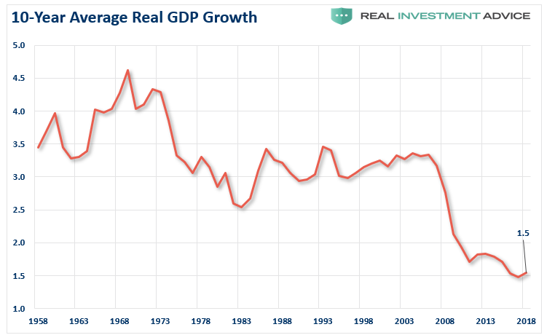

The evidence is also clear that Keynesian central banking is the help-mate of Big Government and the untrammeled expansion of both the Welfare State and Warfare State. That's because the essence of Keynesian central banking is monetization of the public debt----notwithstanding all of obfuscating terminology ---such as Quantitative Easing---that is used to disguise it.
The chart below leaves little to the imagination. The massive explosion of the public debt as a % of GDP is absolutely the by-product of Keynesian central banking and the relentless suppression of interest rates and monetization of the public debt.
In a word, monetization and cheap money removed the "crowding out" effect of high and rising interest rates that pre-1987 politicians deeply feared.
Thus, during the heyday of US economic growth and Light Touch central banking prior to Greenspan, the Federal debt ratio to GDP had steadily fallen. That's because the US had incurred a huge debt burden during WWII (130% of GDP at the 1945 peak), and the trend of the next three decades of cold war peace was for a steady chipping away at that outsized legacy.
Accordingly, the debt ratio bottomed at about 30% in the early 1980s, and was at a rough equilibrium albeit one still higher than the pre-New Deal norm which was actually only 2-5% of GDP. That's because are [our] forefathers knew that debt is an economic growth millstone unless it funds new assets which produce a higher rate of return than the carry cost of the debt.
But 98% of what the government spends money on is inherently incapable of passing that positive yield test because it consists of transfer payments, the Warfare State and domestic boondoggles don't have a prayer of generating positive economic returns.
Needless to say, Volcker refused to monetize Ronald Reagan gigantic albeit unintended debts---so he was fired in 1987. And once Greenspan discovered the printing presses in the figurative basement of the Eccles Building at the time of the Black Monday meltdown, it was off to the monetization races.
He started with $200 billion of Fed balance sheet, which had soared to $800 billion when he left office, and his successors and assigns doubled down from there in attempting to cure the financial market crashes and economic growth shortfalls which were the inherent result of Keynesian central banking.
But the only thing they really did was falsify the price of debt, thereby driving total US private and public debt to $72 trillion or 350% of GDP, where is stands as a millstone on economic growth----even as the public debt continues to rise and after the next recession will be back at 130% of GDP.
That's World War II levels, but, alas, there is no national emergency---just a central bank driven lapse into economic decay and fiscal calamity.
